- Fredericia in numbers
Population: Fredericia (city) 40.248 (2016) and 50.844 (municipality) (2016)
Males: 25.587
Females: 25.257
Area (km2) | 134
Population
1985 | 45.879
2014 | 50.324
Towns with over 1000 inhabitants (2014)
Fredericia | 39.922
Taulov | 3.350
Skærbæk | 2.029

2. Number of Births in Fredericia

The birthrate in Fredericia has increased with 5,8 % from 2006 – 2012.

- Work – Several immigrants and descendants with non-
western origin is going to work
1.1 The employment gap between 25-64 year-old immigrants and descendants
with non-western origin and persons of Danish origin 31 pct. point

- Education – Several immigrants and descendants with non-
western origin is going to must complete a secondary education and a higher education
2.1 The proportion of immigrants (arrived as 0-12 year olds) and descendants with
non-western origin, who pass the grade 2 or above at the 9th grade of the final exam. 76 pct.
in written Danish and mathematical problem solving

  - The proportion of 20-24 year old immigrants (arrived as 0-12 year olds) and
descendants with non-western origin, who have at least completed a secondary 53 pct.
education

  - The proportion of 25-39 year old immigrants (arrived as 0-12 year olds) and
descendants with non-western origin, who have at least completed a higher 21 pct.
education

3. Number of immigrants in Fredericia
2015: Immigrants represents 8,9 % of the population in Denmark.
Immigrants represents 9,8 % of the population in the region of Southern Denmark, equivalent to 92.282 immigrants.
There are populated 3575 immigrants in Fredericia (municipality).
The age at which most immigrants come to Denmark is between 30-39 years.

Employment in Denmark
The three branch groups where most male immigrants are employed is Hotels & Restaurants, Transportation & Travel Services, Cleaning and Other Operational Services.
The three branch groups where most female immigrants are employed is Travel agencies, cleaning and other operational services and hotels and restaurants.

4. Number of refugees in Fredericia
A newspaper article of December 12, 2015 states that 147 refugees are expected to come to Fredericia in 2016.

5. Religions represented and number of churches
- Christianity
- Islam
- Buddhism
- Hinduism
- Judaism

11 churches in the municipality
Bredstrup Kirke
Christianskirken
Egeskov Kirke (Vejlby Sogn)
Erritsø Kirke
Hannerup Kirke
Herslev Kirke
Lyng Kirke
Pjedsted Kirke
Sct. Michaelis Kirke
Taulov Kirke
Trinitatis Kirke

6. Health care and health insurance
In Denmark, everyone who is in a seriously ill state is entitled to free treatment at a hospital. This also applies to guests from other countries.

Everyone who is granted a residence permit and lives in Denmark can freely use the health service. Most examinations and treatments are free. Everyone receives a health card from the municipality. It is a card that should be displayed every time you go to a doctor, at the emergency room and hospital. On your health card, your name, social-security number and contact information are given to your doctor.
You pay a tax to the state that is deducted from your income. In this way you can freely use the Danish health service.

7. Number of suicides
In 2013, there were 605 suicides committed in Denmark. This corresponds to an average of almost two suicides a day.

11.3% of all deaths in 2013 were due to suicide.
In 2015, there were 564 suicides committed in Denmark.
The highest suicide rate is found among people aged 80 or over.
Men commit 75% of all suicide and the remaining 25% are women.

8. Unemployment
In 2012, there were about 1700 full-time unemployed in Fredericia municipality, and by 2015 there were about 1100 full-time unemployed.
The unemployment rate in January 2016 was 4.7% in Fredericia municipality.
The national average was 4.4% in January 2016.

Unemployed
Total 2009 2010 2011 2012 2013 2014 2015
Gross unemployment 130.233 163.460 159.256 161.246 153.092 133.178 122.646 Net unemployment supplementary benefit 83.268 96.412 89.490 98.154 87.288 78.215 74.974
Net unemployment cash benefit recipients 15.017 17.477 18.834 20.636 30.212 28.112 26.779
Activated supplementary beneficients 18.697 34.235 38.098 30.569 20.792 15.599 11.331
Activated cash benefit recipients (prepared for employment) 13.251 15.336 12.834 11.886 14.799 11.252 9.562
Men
Gross unemployment 76.718 96.385 85.885 83.673 78.921 66.635 60.801
Net unemployment supplementary benefit 50.705 57.665 47.776 49.986 43.744 37.707 35.404
Net unemployment cash benefit recipients 8.710 10.164 11.011 12.260 17.562 15.889 14.840
Activated supplementary beneficients 9.188 18.992 19.444 14.430 9.058 6.635 4.958
Activated cash benefit recipients (prepared for employment) 8.115 9.564 7.654 6.998 8.556 6.405 5.600
Women
Gross unemployment 53.515 67.075 73.371 77.572 74.171 66.543 61.844
Net unemployment supplementary benefit 32.562 38.748 41.714 48.169 43.544 40.508 39.570
Net unemployment cash benefit recipients 6.308 7.313 7.823 8.376 12.650 12.223 11.939
Activated supplementary beneficients 9.509 15.242 18.654 16.140 11.734 8.965 6.373
Activated cash benefit recipients (prepared for employment 5.135 5.772 5.180 4.888 6.243 4.847 3.962

Unemployment in Fredericia per. January 2017 | Total | Male | Female
16-24 | 90 | 51 | 39
25-29 | 163 | 78 | 85
30-39 | 328 | 165 | 163
40-49 | 257 | 142 | 115
50-59 | 257 | 124 | 133
60 years or more | 59 | 35 | 24

Young between 18-29 without employment

In September 2015, 186,000 young people were neither in work nor under education in Denmark. This corresponds to every six young Dane.
9. Minimum wage (per hour)

No minimum wage has been set by legislation in Denmark. Solely the social partners without interference with the legislative power determine the wage level in Denmark.
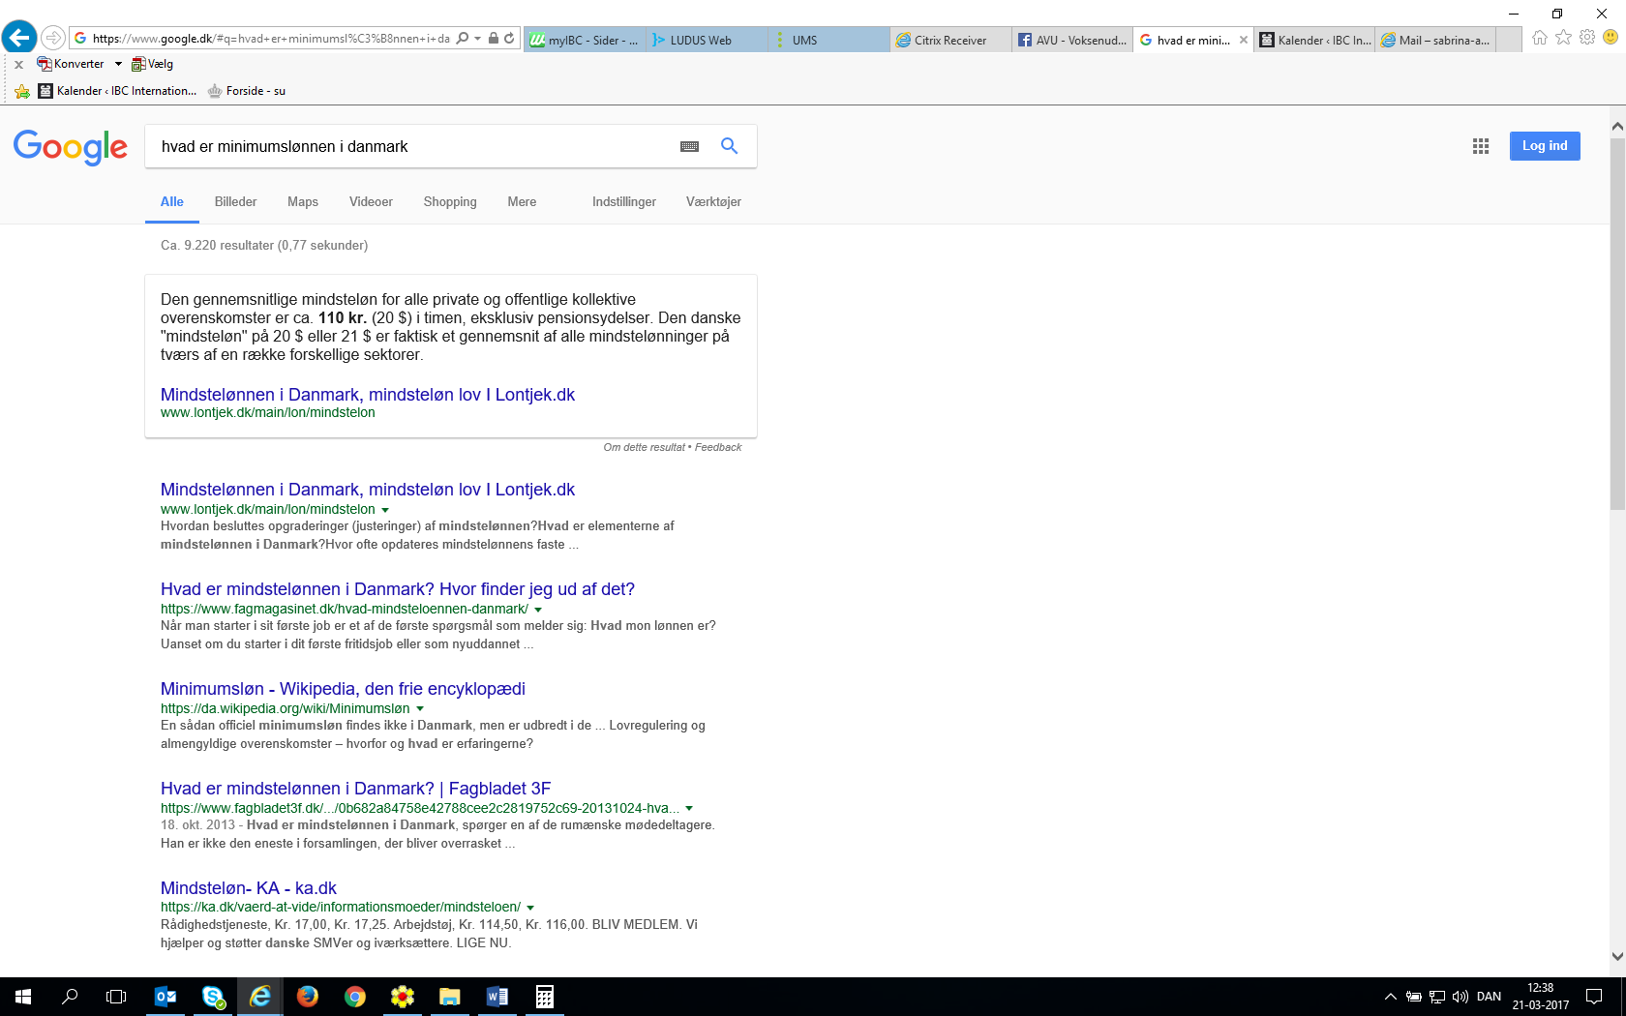
If you work in an area where there is an agreement, there is often a minimum wage, i.e. a lower limit for your salary.
“The average minimum wage for all private and public collective agreements is about $ 20 per hour, excluding pension benefits. The Danish minimum wage of $ 20 is actually an average of all minimum wages across a number of different sectors.”

10. Infrastructure

Towns in Fredericia municipality:
- Erritsø | - Snoghøj | - Pjedsted
- Gammel Pjedsted | - Hannerup | - Taulov
- Herslev | - Vejlby | - Bredstrup
- Lyng | - Bøgeskov | - Trelde
- Skærbæk | - Hybylund | - Nørremark
- Sanddal | - Oddersted | - Østerby
- Trelde Sande | - Egum | - Stallerup
- Ullerup | - Stoustrup | - Bredstruplund
- Follerup | - Surkær | - Tolstrup
- Kongsted | - Højrup | - Børup
- Brovad | - Erritsø Strand | - Tårup
- Studsdal

11. Gender discrimination

In Denmark we have a law that aims to promote equality between women and men, including equal integration, equal influence and equal opportunities in all society's functions based on the equal value of women and men.
The purpose of the Act is also to counteract direct and indirect discrimination on grounds of sex, and to counteract harassment and sexual harassment.

In Denmark, there is a law that prohibits discriminating based on sexual orientation. In addition, people of the same sex are entitled to marry, both civil and ecclesiastical marriage.

