„I Would be a Citizen of the World“ – Finding a proto-european Identity – from regional to transnational actors – through the example of Lord Byron

Introduction

George Gordon Noel Byron, 6. Baron Byron, hereinafter referred to as “Lord Byron”, was an important representative of the 19th century Romantic Movement as well as a key figure in the Greek independence movement. Throughout his life Lord Byron, an English peer, visited numeral European nations. Several of those served him as perennial homes. Byron’s literary achievements, such as Childe Harold’s Pilgrimage and Don Juan were also partly written whilst travelling in Europe.

In literature, Byron is known for his “Byronic Hero”, a kind of anti-hero, which he had modelled largely after his likeness. This type of character is described as lonely, mysterious, seldom smiling and cynical. With a focus on himself, altruism and the greater good are none of his concern. Byron remained true to this stance for a long time.

As early as 1821, Percy Bysshe Shelley and Byron promoted Alexandros Mavrokordatos, a fighter for Greek independence, through propaganda. An idea had set foot in Byron’s mind: National independence efforts, like the recently failed Italian one, became a timeless endeavour. However, Shelley’s enthusiastic outcry “We are all Greeks” is not being shared by Byron yet. [1]

Only after the death of his close friend Shelley in 1822, Byron changed his focus. From this point on he pursued aims resembling those of a tragic hero – where before hedonistic and selfish aims were paramount. In Don Juan his passion for a strive towards freedom becomes evident:

„I wish men to be free

As much from mobs as kings – from you as much as me.”[2]

For most of his lifetime until a few years before his early death, Byron can be seen as an embodiment of his ”Byronic Hero”. As egocentric as his life used to be in the years before Shelley’s death and his identity crisis from 1822 on – in the latter years it changed dramatically. Driven by the thought of filling his life with direction and “glory”, he sought and found a timeless concept – one worthy of dying for. He found this idealised concept in the form of the Greek independence movement, which he supported with his private assets.

Within a year of his passage to Greece, Byron died at the age of 36 due to a fever. Ultimately, Byron outgrew his Byronic Hero. He died a tragic Hero.

„Man’s greatest tragedy is that he can conceive of a perfection which he cannot attain“[3]

Although Greek independence remained an unfulfilled dream until 1827/1830, Lord Byron’s sacrifice remained present long after his time.

Learning Objectives

The aim of this lesson sequence is to establish Lord Byron as a transnational actor, who outgrew his own status as a “Byronic Hero”. Throughout the sequence, the students change the perception they might have established in the first concerning Byron lesson unit. This perception would develop into seeing him as an actor with a proto-European aspect. His determination becomes evident as he brought his own private assets into this cause – along with, ultimately, his life. Still, Byron had little personal gain to expect – renouncing his hedonistic attitude towards one centred around a “greater good”.

The first lesson unit – Introduction to Byron and his times

The first lesson unit serves as an introduction into the complex of themes as well as the character of Lord Byron.

An impulse is being used to showcase Byron as an eccentrically sophisticated peer of British descent. The students research his life and emphasise differences to other members of British nobility. To achieve this, a worksheet containing Byron’s life in a broad perspective is used. Additionally, a video shows a historian’s perspective towards Byron. Several worksheet questions form a subject-specific connection point for the students and eventually serve as a measure of memorising.

|  |  |  |  |
| --- | --- | --- | --- |
| Phase/Time | Expected student behaviour | Planned teacher behaviour | Didactic commentary |
| Introductory Phase  10 min | Discussion about what is seen, differences between the two pictures shown | Using pictures as an impulse | An impulse serves as a starting point and to trigger a student reaction |
| Elaboration Phase  15 min | Reading the text provided (1) and watching the video shown in succession | - | The text broadly introduces Byron while the video translates Byron’s contemporary fame to student’s comprehension |
| Work Phase  10 min | Answering the questions provided corresponding to the text and video | Guiding students if necessary | Students are incentivised in utilising their newly gained knowledge |
| Memorising/Discussion  10 min | Discussion in class about their answers | Moderating the discussion process | A first discussion serves as starting point for the lesson sequence. Results and certain buzzwords are written down on an OHP transparency |

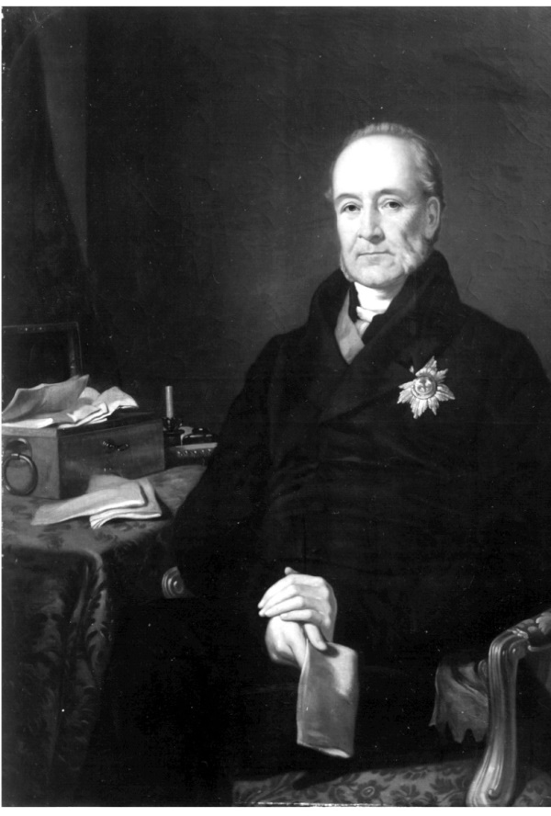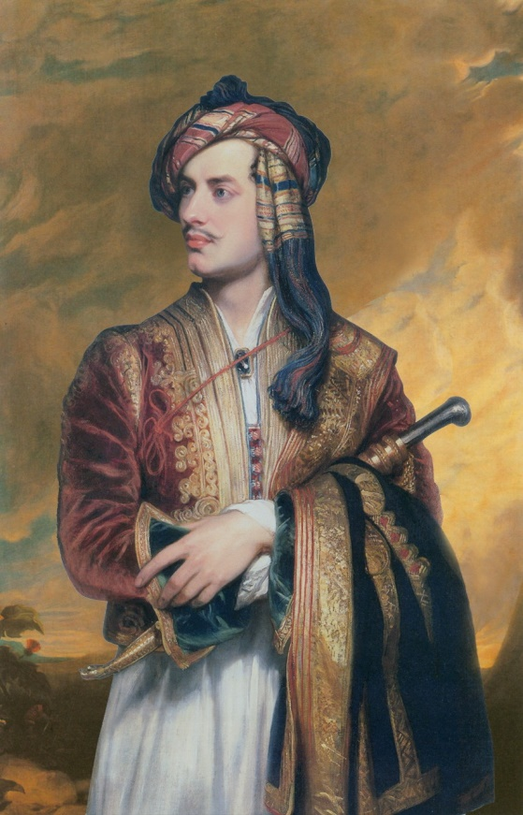

William à Court, 1st Baron Heytesbury GCB PCGeorge Gordon Byron, 6th Baron Byron, FRS

sources:

[https://upload.wikimedia.org/wikipedia/commons/4/4e/William_%C3%A0_Court_2.jpg](https://upload.wikimedia.org/wikipedia/commons/4/4e/William_à_Court_2.jpg) (14.04.2017)

<https://www.bl.uk/collection-items/byron-portrait> (14.04.2017)

* https://www.youtube.com/watch?v=gn1sS9kz2ms
* MASSOLIT: The Life of Lord Byron (Stand: 18.09.2017)

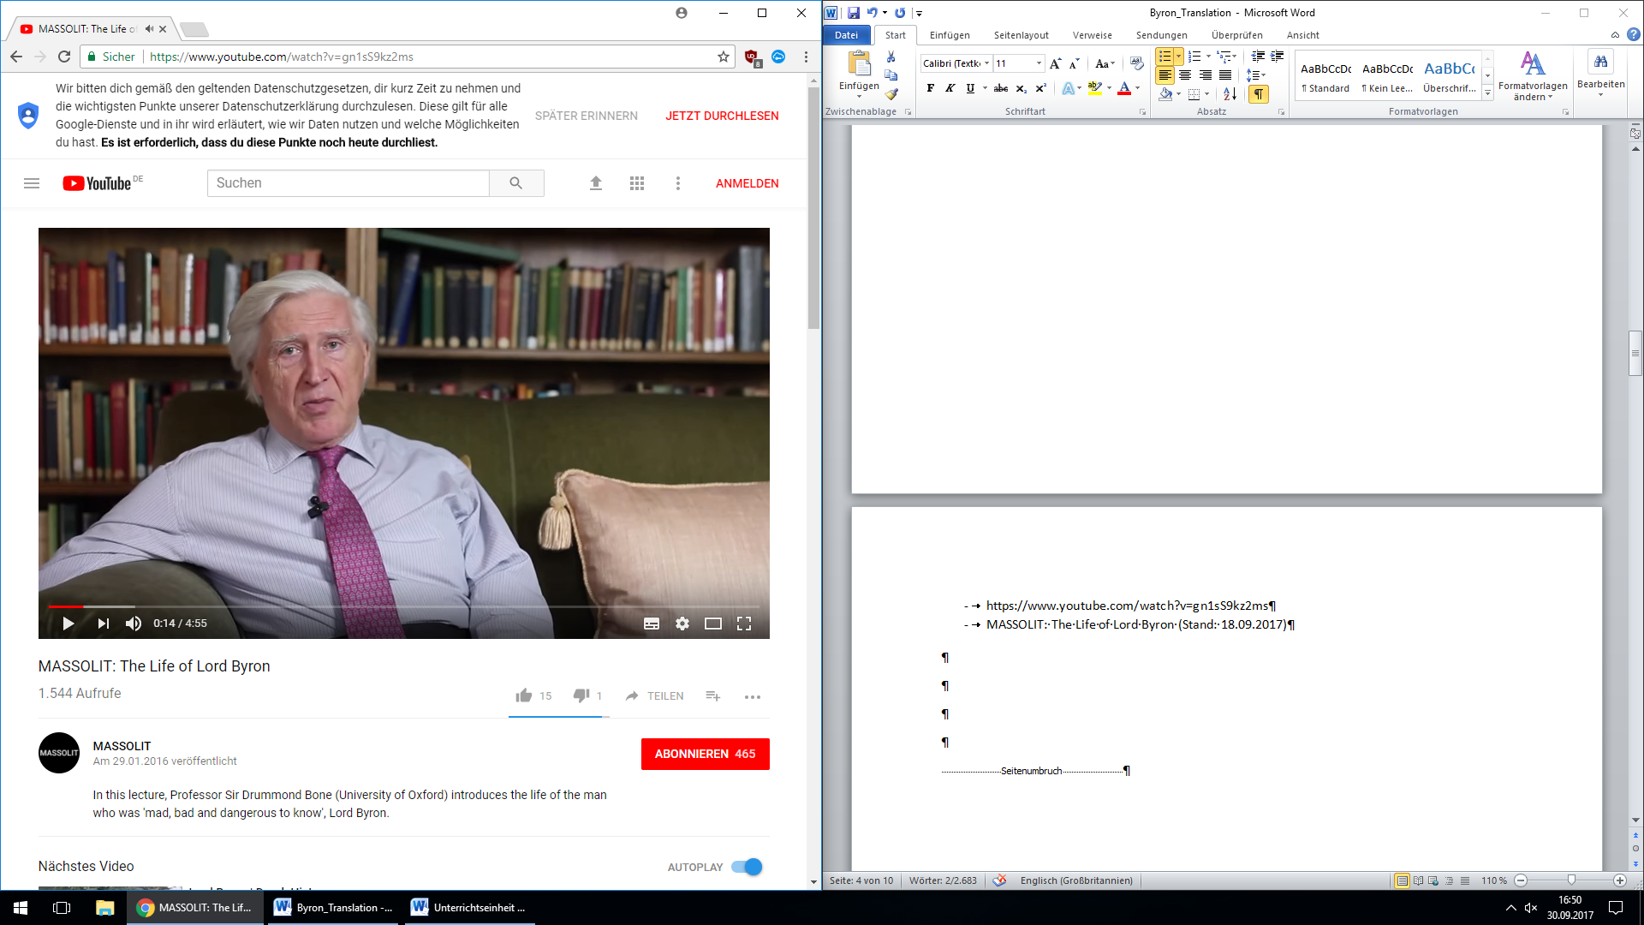

Work sheet 1.1

Byron was the ideal of the Romantic poet, gaining notoriety for his scandalous private life and being described by one contemporary as 'mad, bad and dangerous to know'.

George Gordon Noel, sixth Baron Byron, was born on 22 January 1788 in London. His father died when he was three, with the result that he inherited his title from his great uncle in 1798.

Byron spent his early years in Aberdeen, and was educated at Harrow School and Cambridge University. In 1809, he left for a two-year tour of a number of Mediterranean countries. He returned to England in 1811, and in 1812 the first two cantos of 'Childe Harold's Pilgrimage' were published. Byron became famous overnight.

In 1814, Byron's half-sister Augusta gave birth to a daughter, almost certainly Byron's. The following year Byron married Annabella Milbanke, with whom he had a daughter, his only legitimate child. The couple separated in 1816.

Facing mounting pressure as a result of his failed marriage, scandalous affairs and huge debts, Byron left England in April 1816 and never returned. He spent the summer of 1816 at Lake Geneva with Percy Bysshe Shelley, his wife Mary and Mary's half-sister Claire Clairmont, with whom Byron had a daughter.

Byron travelled on to Italy, where he was to live for more than six years. In 1819, while staying in Venice, he began an affair with Teresa Guiccioli, the wife of an Italian nobleman. It was in this period that Byron wrote some of his most famous works, including 'Don Juan' (1819-1824).

In July 1823, Byron left Italy to join the Greek insurgents who were fighting a war of independence against the Ottoman Empire. On 19 April 1824 he died from fever at Missolonghi, in modern day Greece. His death was mourned throughout Britain. His body was brought back to England and buried at his ancestral home in Nottinghamshire.

<http://www.bbc.co.uk/history/historic_figures/byron_lord.shtml> (Stand: 14.04.2017)

* Lord Byron was a representative of which literary movement?
* Would he be considered as conservative or left-leaning? Why?
* In your opinion: was Lord Byron a typical member of British aristocracy? Why? Why not?

The second lesson unit – The Byronic Hero in practice

The Byronic Hero is central to this lesson unit. The students will not only learn key characteristics, but also apply and transfer them to their own literary figures.

This unit starts with an impulse picking up at Byron’s life from the first lesson unit and introducing the cultural-historical period of romanticism. In doing so the students are being tasked to describe a painting by the artist Caspar David Friedrich “Wanderer above the Sea of Fog”. Ideally, the students pinpoint traits shown by the “Wanderer”, which widely match those of the “Byronic Hero”. The Byronic Hero will then form the major subject of this lesson unit. Sought after traits would be: loneliness, egocentrism, sensibility, a turn from society (among others).

A first point of contact with Lord Byron’s literary achievements serves as a means of bridge building towards the Byronic Hero. The students receive a worksheet with an excerpt of Byron’s poem “The Corsair” – with the assignment to analyse the displayed character properties.

He knew himself a villain—but he deem'd

The rest no better than the thing he seem'd;

And scorn'd the best as hypocrites who hid

Those deeds the bolder spirit plainly did.

He knew himself detested, but he knew

The hearts that loath'd him, crouch'd and dreaded too.

Lone, wild, and strange, he stood alike exempt

From all affection and from all contempt: (I, XI)

The Corsair (1814)

Also part of the analysis is the comparison of this anti-hero type with other figures in literary or pop-culture (for example: Jay Gatsby in F. Scott Fitzgeralds novel “The Great Gatsby” or Severus Snape in J. K. Rowlings “Harry Potter” series). The results from this analysis are written down by the teacher as a measure of memorising. Following this task, the differences and similarities between the classical hero and the Byronic Hero are being researched. Lastly, the students internalise this concept by applying the filter on literary hero figures of their own choosing, which are being exemplarily presented in class.

The main aim of this lesson unit is the understanding and categorisation of the Byronic Hero into the period of romanticism as well as the transfer of the lesson’s knowledge. The Byronic Hero will be an important concept for the following lesson units, where Byron’s estrangement will become evident.

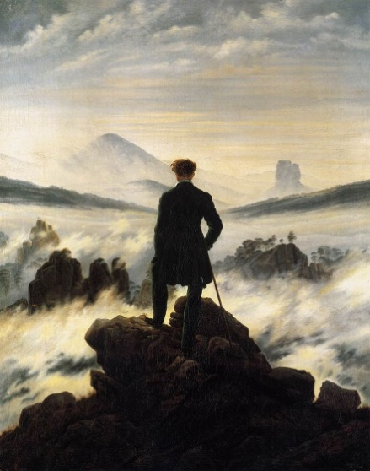

Wanderer above the Sea of Fog, Caspar David Friedrich (1819), source: <https://upload.wikimedia.org/wikipedia/commons/b/b9/Caspar_David_Friedrich_-_Wanderer_above_the_sea_of_fog.jpg> (14.04.2017)

Work sheet 2.1

The Corsair (1814)

He knew himself a villain—but he deem'd

The rest no better than the thing he seem'd;

And scorn'd the best as hypocrites who hid

Those deeds the bolder spirit plainly did.

He knew himself detested, but he knew

The hearts that loath'd him, crouch'd and dreaded too.

Lone, wild, and strange, he stood alike exempt

From all affection and from all contempt: (I, XI)

* Analyse the poem
* How would you characterise the protagonist?
* Is there a literary figure that resembles this one?

Definition Byronic Hero

The Byronic hero first appears in Byron's semi-autobiographical epic narrative poem Childe Harold's Pilgrimage (1812–1818). Historian and critic Lord Macaulay described the character as "a man proud, moody, cynical, with defiance on his brow, and misery in his heart, a scorner of his kind, implacable in revenge, yet capable of deep and strong affection".[1] The initial version of the type in Byron's work, Childe Harold, draws on a variety of earlier literary characters including Hamlet, Goethe's Werther (1774), and William Godwin's Mr. Faulkland in Caleb Williams (1794); he was also noticeably similar to René, the hero of Chateaubriand's novella of 1802, although Byron may not have read this.

Name a Byronic Hero: _______________________________

What would a classical hero be? _______________________________

Discuss your examples with your neighbour.

|  |  |  |  |
| --- | --- | --- | --- |
| Phase/Time | Expected student behaviour | Planned teacher behaviour | Didactic commentary |
| Introductory Phase  10 min | Describing the painting, analysing the content | Guiding student’s attention | The painting introduces characteristics of the Byronic Hero for further study |
| Elaboration Phase  15 min | Reading and analysing the poem “The Corsair” by Byron | Helping the students pinpoint Byronic Hero characteristics and what sets him apart from a classical hero | The students further deepen their understanding of Byron’s character and his literary self |
| Work Phase  10 min | Answering worksheet-provided questions | - | The questions provided lead to a full understanding of the concept as well as an adaptation of the knowledge gained (providing own examples) |
| Memorising/Discussion  10 min | Discussing the results in class | Moderating the discussion | By providing own examples the concept is reinforced and memorised via OHP-transparency |

The third lesson unit – Byron as a transnational actor

The third lesson unit introduces the concept of Lord Byron as a transnational actor by focussing on his actions outside of Great Britain. This becomes relevant in a later lesson unit as the notion of a “European” actor becomes central.

Starting with an impulse via the painting “The Reception of Lord Byron at Missolonghi“ by Theodoros Vryzakis. For the first time, the students are faced with Byron’s “European” ambitions as they analyse Greek fighters for independence meeting Byron. The aim of this impulse is the development of a connection between Byron and the Greek independence movement.

Byron’s role in this movement becomes more evident with a text analysis being conducted in two groups. The first group analyses a text about the concept of philhellenism and how it can be applied to Byron. The second group further dives into Byron’s sense of heroism and how he develops a stance towards a “cause”. The respective groups’ results are recorded on posters which are eventually displayed and explained by each group. The posters, along with the explanations form a measure of memorising the complex topics and can be used during the following lesson units.

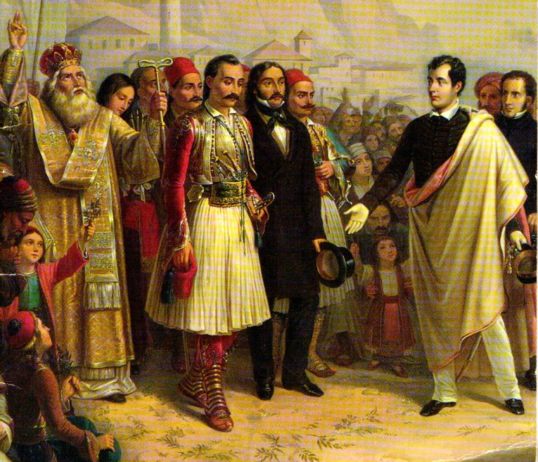

The Reception of Lord Byron at Missolonghi, Theodore Vryzakis (1861), source: <https://upload.wikimedia.org/wikipedia/commons/1/1a/Lord_Byron_at_Missolonghi.jpg> (14.04.2017)

Byron, The Isles of Greece

The mountains look on Marathon --

And Marathon looks on the sea;

And musing there an hour alone,

I dream'd that Greece might yet be free

For, standing on the Persians' grave,

I could not deem myself a slave.

...

Must we but weep o'er days more blest?

Must we but blush? – Our fathers bled.

Earth! render back from out thy breast

A remnant of our Spartan dead!

Of the three hundred grant but three,

To make a new Thermopylae.[4]

Work sheet 3.1 (Group 1)

Philhellenism in its times

Philhellenism as an intellectual and ideological movement of western European citizens circles around the appreciation of (classical) Greek antiquity as well as its adaptation in the time of enlightenment. Yet not every philhellene saw the classic Hellas or a legitimation for a free and modern state when gazing upon Greece. Leading characters among philhellenes, such as Lord Byron have shown genuine interest and sympathy with the fate of contemporary Greece. Byron even sacrificed his life in the Greek War of Independence 1821-1829. During the time of these struggles, the Greek contemporary has always been regarded as a natural and legitimate means to realise the dream of a liberated Greece.

The Ideology of Philhellenism

Philhellenism was a political movement aiming at the liberation of Greece from Ottoman rule. Secondly, it strode to form an independent Greek state, as numerous pamphlets and books circulating in philhellene-societies during the early 19th century depict. Insurgent Greeks, who presented their ideas in front of European national assemblies, oftentimes emphasised cultural similarities between themselves and (western) Europeans. One of those frequently used similarities was Christianity – by relativising and suppressing “oriental” aspects of orthodox Christianity.

This religious justification of a struggle of faith between “Christianity” and the Ottoman Muslims reinforced and fueled the philhellene’s persuasiveness. This contributed to the wide spread and systematic organisation of philhellenism in Western Europe unlike any movement since the medieval crusades.

During the Greek War of Independence (1821-1829) in April 1822 the Ottomans perpetrated a massacre among the inhabitants of the island of Chios, murdering more than 20.000 people and enslaving about 45.000. This act led to an outrage in Europe, reinforced the negative stereotype of the “savage Ottoman” and served as a boost for political philhellenism.

Philhellenism as a defining moment for Europe

The philhellene’s participation during the Greek War of Independence was being justified as peace enforcing, downright humanitarian in its nature. One appealed to Europe in the name of humanity – thus the War of Independence was being perceived as one of liberation. An astounding aspect is the attempt of reinforcing the legal legitimacy of the war within the framework of applicable international law. This attempt is also of importance as the Greek revolution has hitherto been regarded as an uprising of citizens against their sovereign ruler, the Ottoman sultan. Until then, this was consensus among the powerful rulers of Europe.

Fittingly, the national assembly at Troizen (1827) proclaimed: “Our war does not originate in an uprising against a legitimate ruler.” The then following change of heart of the powerful substantially led to the success of the war and ultimately, the foundation of the state of Greece. Hence, all this took place under the impression of a tremendous scientific and publicist “campaign”.[5]

Work sheet 3.2 (Group 2)

This excerpt of Lord Byron’s poem “The Corsair (1814)” deals with the pirate Character Conrad:

He knew himself a villain—but he deem'd

The rest no better than the thing he seem'd;

And scorn'd the best as hypocrites who hid

Those deeds the bolder spirit plainly did.

He knew himself detested, but he knew

The hearts that loath'd him, crouch'd and dreaded too.

Lone, wild, and strange, he stood alike exempt

From all affection and from all contempt: (I, XI)

Task: Interpret this excerpt.

* How is Conrad depicted?
* Could Conrad be seen as “heroic”? Why? Why not? Discuss!
* What would Byron’s rendition of a hero be?

The following is an excerpt from Lord Byron’s poem “The Island or: Christian and his Comrades (1823)”, about a mutiny on a ship. The mutineers are depicted as follows:

[…]

They stood, the three, as the three hundred stood

Who dyed Thermopylae with holy blood.

But, ah! how different! ‚tis the cause makes all,

Degrades or hallows courage in its fall.

O’er them no fame, eternal and intense,

Blazed through the clouds of death and beckoned hence;

No grateful country, smiling through her tears,

Begun the praises of a thousand years;

No nation’s eyes would on their tomb be bent[.]

No heroes envy them their monument;

However boldly their warm blood was spilt,

Their Life was shame, their Epitaph was guilt.[6]

Task: Interpret this excerpt.

* What is meant by “cause makes all”?
* According to Byron – are the mutineers heroic?
* Why would their epitaph be guilt?
* Would Byron’s epitaph be guilt as well?

|  |  |  |  |
| --- | --- | --- | --- |
| Phase/Time | Expected student behaviour | Planned teacher behaviour | Didactic commentary |
| Introductory Phase  10 min | Describing the painting, analysing the content | Guiding student’s attention – answering questions accordingly | The painting confronts the students with Byron’s transnational actions |
| Group Work Phase  20 min | Two groups are being formed – students work on their posters explaining their topic | Guiding the groups | The two groups each gain specialised knowledge about a topic. This knowledge will be shared with the other group subsequently |
| Memorising/Discussion  15 min | Students present their findings and their text to the other group | Moderating the exchange if necessary | By writing down results and presenting them, students memorise and transfer the knowledge gained |

The fourth lesson unit – Byron as a proto-european?

The fourth lesson unit is conducted under the topic of whether or not Lord Byron could be seen as a proto-european in the light of the discoveries throughout the lesson sequence. Students will need to utilise their knowledge of the previous lesson units in order to participate.

The lesson unit is introduced by using a quotation by Roderick Beaton on Lord Byron:

“Byron’s tribute to Shelley, finally, will not be a poem, but a war. His will be a tribute not of words but of deeds![7]”

Following this quotation, the students will discuss the meaning in class. At the teacher’s disposal are several questions to direct the debate into certain directions of the analysis.

* Who was Shelley? In what way did he influence Byron?
* What is meant by “tribute not of words but of deeds”?

After concluding the analysis, an article about Europe is handed out. This article highlights the question what it is to be European with an emphasis on a modern European concept. The students are being challenged into determining whether Byron could be seen as “European” - one of the key questions for this lesson sequence. Still, the results each student develops will not be shared publicly yet. The students are given an additional work phase of 5 minutes, during which they are able to take notes for the final discussion of the topic.

Lastly, the students are familiarised with the concept of the fishbowl method. In this method, four to five chairs are being arranged in an inner circle (which would be the fish bowl). The remaining chairs are arranged in circles outside the fishbowl. One chair would remain empty. The moderator fills the chairs with students, introduces the topic and the participants start the discussion. The outer rows listen to the discussing participants. During the discussion, any member of the audience is able to join the discussion via the empty inner chair. When this happens, an existing member of the inner circle must leave to make room for another. The teacher only intervenes in case the discussion turns off topic.

As a means of memorising, the teacher takes notes on certain keywords on an OHP-transparency.

Work sheet 4.1

In 1948 at the Congress of Europe, Winston Churchill said, ''We hope to see a Europe where men of every country will think of being a European as of belonging to their native land, and . . . wherever they go in this wide domain . . . will truly feel 'Here I am at home.''' The exiled diplomat Salvador de Madariaga said: ''This Europe must be born. And she will, when Spaniards say 'our Chartres,' Englishmen 'our Cracow,' Italians 'our Copenhagen,' when Germans say 'our Bruges.' . . . Then will Europe live. For then it will be that the spirit that leads history will have uttered the creative words: fiat Europa.''

[…]

One thing Europeans all have in common -- whether they like it or not -- is a sense of a deep and complicated past. Even students, asked what being European means to them, will say, ''Well, we are old, our countries are old, there is all this history.'' They don't so much mean ''heritage,'' cloisters and frescoes, castles and styles of glass and ceramics, though that is included. They mean things like the sense of identity and antagonism in the Balkans that goes back at least as far as the Ottoman Empire. Another person I used to talk to on my French mountain was a wandering ex-schoolmaster with a black dog. I remember a very civilized discussion about reasons for changing the bloodthirsty words of the ''Marseillaise'' in the new Europe. ''We must be peaceful in these days,'' he said, and suddenly turned on me, bristling with national pride and observed that ''C'est vous en effet, l'ancien ennemi'' (''You are our hereditary enemy''). I felt hated, back in the Middle Ages, when the English marched armies across this country, which had never been forgotten.

But the past that does weld modern Europeans together is the recent past that divided them so bitterly. The founders of the European Union were possessed by horror and an idealistic desire to ensure that these events were at an end and could not be repeated. ''What is Europe now?'' Churchill asked. ''It is a rubble heap, a charnel house, a breeding ground of pestilence and hate.'' The future of Europe, he said earlier, depended on ''the resolve of hundreds of millions . . . to do right instead of wrong.''

[…]

What is a European according the author?

Would you consider Lord Byron to have been “European”? Why? Why not?

|  |  |  |  |
| --- | --- | --- | --- |
| Phase/Time | Expected student behaviour | Planned teacher behaviour | Didactic commentary |
| Introductory Phase  10 min | Analysing the quotation | Offering additional research questions | The students are being directed into researching Byron’s motives in latter life |
| Elaboration Phase  10 min | Analysing a text about what it is to be European | - | Byron can now be analysed from a broader perspective and tested on “compatibility” to an idea of Europe |
| Work Phase  5 min | Making notes about the questions provided with the text for the final discussion panel | Offering guidance | The students prepare themselves for the final discussion panel (fishbowl) and prepare their notes with the help of questions |
| Memorising/Discussion  20 min | Using the Fishbowl method to discuss whether or not Byron could be seen as a European along with his personal development (Byronic Hero vs. traditional Hero) | Moderating the Fishbowl method – appointing speakers and setting up topical boundaries | The students ultimately each make a case for or against the character of Lord Byron in the light of a transnational (European) actor. The teacher serves as a moderator and eventually makes notes on an OHP-transparency |

1. Beaton, Roderick: Byron’s War – Romantic Rebellion, Greek Revolution, Cambridge University Press, Cambridge, UK, 2014, S. 87, im Folgenden abgekürzt als: Byron’s War
2. Byron’s War, S. 112
3. McGann, ed, Byron: The Complete Poetical Works, ed. With Introduction, Apparatus and Commentaries, 7 Vols., Clarendon Press, The Oxford English Texts series, 1980-1993
4. Eva March Tappan, ed., The World's Story: A History of the World in Story, Song and Art, 14 Vols., (Boston: Houghton Mifflin, 1914), Vol. IV:Greece and Rome, S. 228-231
5. see Chrysos, Evangelos for bpb: <http://www.bpb.de/geschichte/zeitgeschichte/griechenland/176411/die-entstehung-des-griechischen-staates-und-der-geist-des-philhellenismus> (14.04.2017)
6. Island IV 261-7 in: Byron’s War, S. 123f
7. Beaton, Roderick: Byron’s War, p. 112