QUANTITATIVE INFORMATION.

1.- BASIC INFORMATION OF THE REGION. DEMOGRAPHICAL APPROACH. (TOWN HALL)
- NAME OF TOWN AND NUMBER OF INHABITANTS.
POPULATION OF THE REGION OF MURCIA: 1.464.440. (2015) 2.848 FEWER THAN THE PREVIOUS YEAR.
MURCIA REPRESENTS THE 3RD PER CENT OF THE SPANISH TERRITORY.
MURCIA IS THE 10TH REGION IN SPAIN IN TERMS OF POPULATION.
- GENDER. MEN REPRESENT THE 50.08% OF THE POPULATION WHEREAS WOMEN ARE THE 49.92%

2 - BIRTH RATE
DATE | BIRTHS | MEN | WOMEN | BIRTH RATE
2015 | 15.947 | 8.160 | 7.787 | 10,90‰
2014 | 16.308 | 8.493 | 7.815 | 11,15‰
2013 | 16.105 | 8.294 | 7.811 | 11,02‰
2012 | 16.682 | 8.681 | 8.001 | 11,42‰
2011 | 17.408 | 9.005 | 8.403 | 11,91‰
2010 | 18.039 | 9.320 | 8.719 | 12,38‰
Murcia - Natalidad

3- NUMBER OF MIGRANTS AND NATIONALITY.
THE REGION OF MURCIA IS THE 4TH IN SPAIN WITH REGARDS TO FOREIGN INHABITANTS.
MIGRANTS ARE USUALLY YOUNG WITH AN AVERAGE AGE OF 34.
41.33% OF MIGRANTS DEVELOP THEIR WORK IN AGRICULTURE AND DOMESTIC CHORES. CARING FOR THE ERDERLY IS ANOTHER OCCUPATION PARTICULARLY DEVELOPED BY FEMALE MIGRANTS.
MURCIA IS THE 5TH COMMUNITY IN NUMBER OF MUSLIMS (APRIL 2015)
-
4 - NUMBER OF REFUGEES. (NGOs)
HERE IN SPAIN WE ONLY HEAR PROMISES OF REFUGEES COMING BUT THERE IS NO SIGHT OF THEM.
A NEWSPAPER ARTICLE DATED 9/9/2015 SAID THAT 500 REFUGEES MIGHT COME TO MURCIA SHORTLY. WE STILL DON`T KNOW THE EXACT NUMBER OF REFUGEES IN OUR REGION.

5- RELIGION (RELIGIOUS COMMUNITIES). NUMBER OF CHURCHES / MOSQUES
CATHOLIC 90.3% 292 TEMPLES IN THE REGION
OTHER RELIGIONS 0.5%
- Evangelical : 14
- Muslims 30
NON BELIEVERS 7.6%
ATHEIST 1.6%
SOURCE: SOCIOLOGICAL RESEARCH CENTRE (2015)

6.- HEALTH CARE. HEALTH INSURANCE.
OUR HEALTH CARE SYSTEM IS PUBLIC AND FREE OF CHARGE. IT IS SUSTAINED BY SOCIAL SECURITY PAYMENTS WHICH ARE DEDUCTED FROM THE WORKERS` WAGES.
AS FOR FOREIGNERS, THOSE WHO ARE REGISTERED IN SPAIN IN THE MUNICIPALITY IN WHICH THEY ARE HABITUALLY RESIDENTS HAVE THE RIGHT TO HEALTH SERVICES ON THE SAME CONDITIONS AS THE SPANISH.
FOREIGNERS WHO ARE IN SPAIN HAVE THE RIGHT TO URGENT HEALTH SERVICES IN THE EVENT OF CONTRACTING SEVERE ILLNESS OR HAVING AN ACCIDENT, WHATEVER MAY BE THE CAUSE.
IN CONCLUSION, PEOPLE ARE ENTITLED TO FREE STATE HEALTH CARE IF THEY ARE:
- RESIDENT IN SPAIN AND WORK AND PAY SOCIAL SECURITY CONTRIBUTIONS.
- PEOPLE UNDER 18
- PREGNANT WOMEN
- STATE PENSIONER
- STAYING TEMPORARILY IN SPAIN AND HAVE AN EHIC (EUROPEAN HEALTH INSURANCE CARD)

7- SUICIDE RATE (DATA FROM 2013)

IN MURCIA, SUICIDE RATE DECREASED THE 4% IN 2013.
IN SPAIN IT INCREASED THE 2%.
102 PEOPLE COMMITED SUICIDE. 2 PEOPLE PER WEEK. 4 PEOPLE FEWER THAN IN 2012.
AS REGARDS SEXES:
MEN: 78 COMMITED SUICIDE. 9% LESS THAN IN 2012
WOMEN: 24 SUICIDES. 20% MORE THAN IN 2012.
MURCIA IS THE 4TH REGION IN SPAIN WITH THE LOWEST SUICIDE RATE. MADRID , CANTABRIA AND EXTREMADURA OCCUPY THE 3 FIRST PLACES IN THAT ORDER.

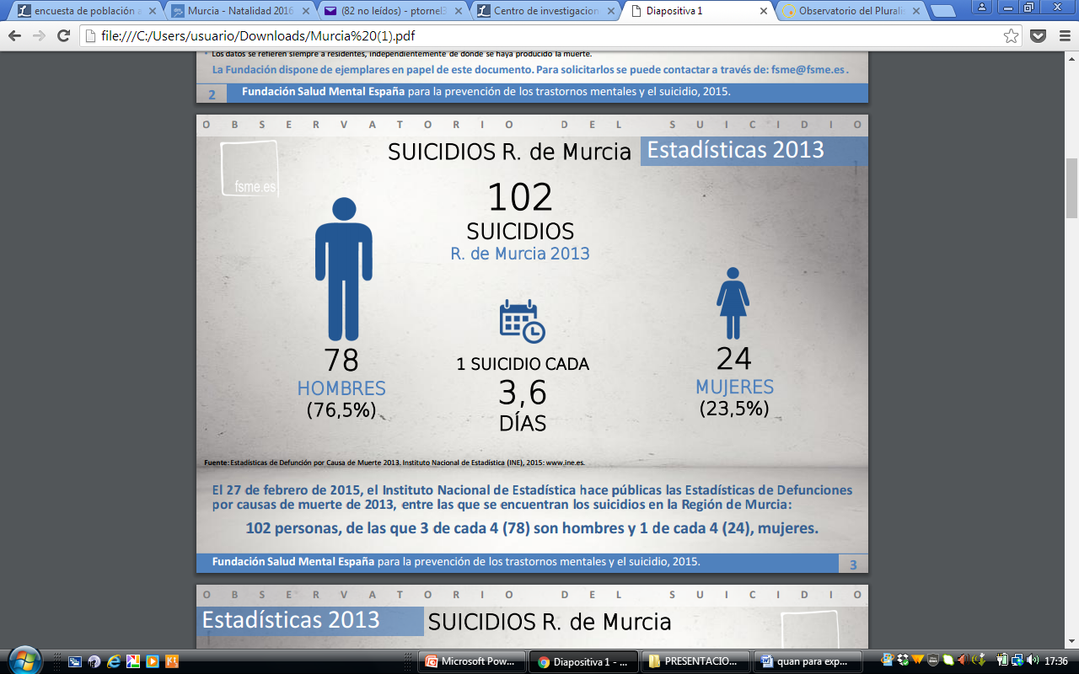

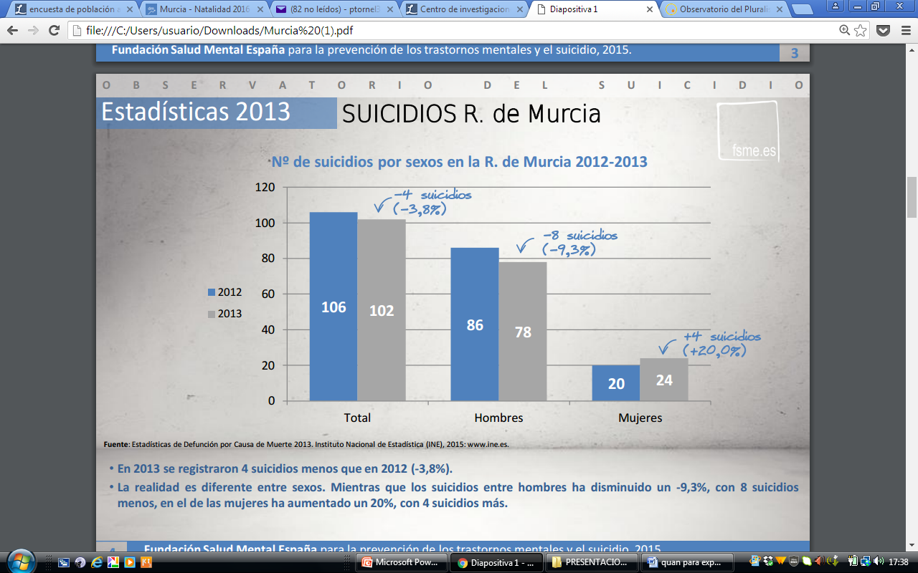

8.- UNEMPLOYMENT.
EPA Murcia II Trim 2016
 | Total | MEN | WOMEN
< EPA 2016-03
TOTAL OF UNEMPLOYED | 131 m. | 66 m. | 65 m.
UNDER 25 [+] | 25 m. | 14 m. | 11 m.
OVER 25 [+] | 106 m. | 52 m. | 54 m.
UNDER 20 [+] | 6 m. | 4 m. | 2 m.
BETWEEN 20 y 24 [+] | 19 m. | 11 m. | 8 m.
BETWEEN 25 y 54 [+] | 89 m. | 41 m. | 48 m.
OVER 55 [+] | 18 m. | 11 m. | 7 m.

2015 2014
UNEMPLOYMENT RATE (EPA) | 23,5% | 27,3%
MEN | 20,6% | 25,3%
WOMEN | 27,3% | 29,8%
UNDER 25 | 50,2% | 58,4%
MEN UNDER 25 | 48,1% | 51,5%
WOMEN UNDER 25 | 53,3% | 66,6%

UNEMPLOYED PEOPLE FROM 20 TO 24 YEARS OF AGE IN SPAIN. (JULY 2016)

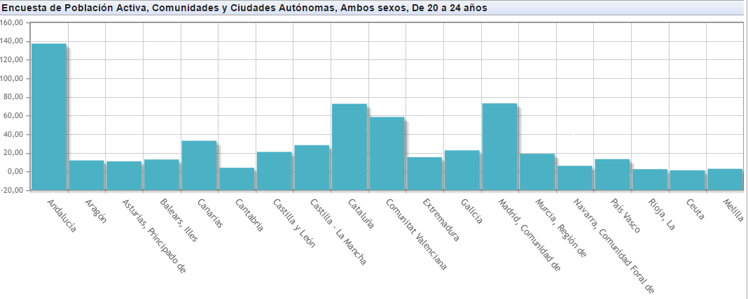
(Labour force survey)

9- MINIMUM WAGE (PER HOUR)
YEAR PER DAY PER MONTH
---- ------- --------
2016 21,84 € 655,20 €
2015 21,62 € 648,60 €
2014 21,51 € 645,30 €
2013 21,51 € 645,30 €

- FULL TIME OR PART TIME?
PART-TIME: 86.800
FULL-TIME: 483.600

10.- Murcia es la cuarta región con mayor porcentaje de 'ninis'.

MURCIA IS THE 4TH REGION WITH THE HIGHEST PERCENTAGE IN “NINIS” (YOUNG PEOPLE WHO NEITHER WORK NOR STUDY)

NINI: A PERSON WHO IS BETWEEN 18 AND 29 YEARS OF AGE AND NEITHER WORKS OR STUDIES
1.- CANARY ISLANDS (24.2%)
2.- ANDALUCIA (24.1%)
3.- EXTREMADURA (23.3%)
22,5% DE LOS JÓVENES MURCIANOS NO ESTUDIAN NI TRABAJAN, DE ACUERDO A LOS DATOS DEL MINISTERIO DE EDUCACIÓN.
(22,5% OF YOUNGSTERS IN MURCIA NEITHER WORK OR STUDY, ACCORDING TO THE MINISTRY OF EDUCATION)
19,4% ES EL PORCENTAJE MEDIO DE “NINIS” EN ESPAÑA . SE HA REDUCIDO UN 1.3% EN EL ÚLTIMO AÑO.
19,4% IS THE AVERAGE PERCENTAGE OF “NINIS” IN SPAIN. LUCKILY, IT HAS BEEN REDUCED IN 1.3% WITH RESPECT TO THE PREVIOUS YEAR,

14,8% ES EL PORCENTAJE DE LOS PAÍSES DE LA UE.
14,8% IS THE AVERAGE PERCENTAGE OF “NINIS” IN THE UE COUNTRIES.
(THIS INFORMATION MAKES REFERENCE TO THE LAST TERM OF 2015)
http://www.laverdad.es/murcia/201605/30/murcia-cuarta-region-mayor-20160530013730-v.html

10- INFRASTRUCTURE.
Neighbourhoods
.
- 01 - Barriomar  - 02 - El Carmen  - 03 - Infante Juan Manuel  - 04 - La Fama  - 05 - La Flota  - 06 - La Paz - Vistabella  - 07 - San Andrés  - 08 - San Antolín  - 09 - San Antón  - 10 - San Basilio- Santa María de Gracia  - 11 - San Juan | - 12 - San Lorenzo  - 13 - San Miguel  - 14 - San Nicolás  - 15 - San Pedro  - 16 - San Pío X  - 17 - Santa Catalina  - 18 - Santa Eulalia  - 19 - Santa María - San Bartolomé  - 20 - Santiago El Mayor  - 21 - Vistalegre  - 22 - Espinardo

B- VOTES IN ELECTIONS BY NEIGHBOURHOODS
ELECCIONES GENERALES (20 de Noviembre de 2011)
NEIGHBOURHOOD | ELECTORATE | TOTAL OF VOTES | NULL VOTES | BLANK VOTES | PP | PSOE | IU | UPyD | OTHERS
BUENOS AIRES | 2032 | 1530 | 15 | 22 | 864 | 295 | 143 | 143 | 48
CARMEN (EL) | 13772 | 10736 | 107 | 110 | 6490 | 1874 | 764 | 1095 | 296
CATEDRAL (LA) | 1760 | 1403 | 9 | 12 | 1058 | 126 | 44 | 129 | 25
ESPINARDO | 7931 | 5751 | 45 | 50 | 3465 | 1212 | 343 | 487 | 149
FAMA (LA) | 5431 | 4362 | 28 | 36 | 3177 | 460 | 191 | 366 | 104
FLOTA (LA) | 5776 | 4667 | 46 | 52 | 2719 | 775 | 303 | 624 | 148
INFANTE JUAN MANUEL | 10537 | 8255 | 66 | 86 | 4894 | 1484 | 584 | 939 | 202
PAZ (LA) | 3009 | 1937 | 17 | 25 | 1241 | 390 | 128 | 100 | 36
PURISIMA (LA)-BARRIOMAR | 2297 | 1631 | 14 | 14 | 1133 | 246 | 96 | 77 | 51
RANERO (EL) | 2924 | 2326 | 18 | 30 | 1389 | 412 | 141 | 278 | 58
SAN ANDRES | 1512 | 1181 | 13 | 12 | 733 | 215 | 62 | 111 | 35
SAN ANTOLIN | 3372 | 2565 | 21 | 19 | 1663 | 416 | 155 | 208 | 83
SAN ANTON | 6587 | 5335 | 57 | 59 | 3332 | 924 | 286 | 530 | 147
SAN BARTOLOME | 987 | 797 | 4 | 6 | 622 | 68 | 21 | 64 | 12
SAN BASILIO | 3797 | 2877 | 31 | 33 | 1613 | 610 | 220 | 314 | 56
SAN JUAN | 3738 | 2908 | 22 | 28 | 1788 | 509 | 199 | 273 | 89
SAN LORENZO | 2382 | 1941 | 13 | 34 | 1385 | 245 | 80 | 145 | 39
SAN MIGUEL | 6574 | 5470 | 26 | 45 | 4275 | 496 | 150 | 385 | 93
SAN NICOLAS | 2368 | 1856 | 21 | 19 | 1238 | 279 | 90 | 168 | 41
SAN PEDRO | 1335 | 1023 | 7 | 4 | 712 | 131 | 55 | 87 | 27
SAN PIO X | 1830 | 1367 | 13 | 12 | 847 | 255 | 99 | 116 | 25
SANTA CATALINA | 1288 | 1083 | 3 | 5 | 840 | 110 | 37 | 70 | 18
SANTA EULALIA | 2159 | 1656 | 10 | 20 | 1044 | 269 | 133 | 129 | 51
SANTA MARIA DE GRACIA | 9639 | 7646 | 61 | 81 | 4725 | 1340 | 457 | 756 | 226
SANTIAGO EL MAYOR | 5576 | 4329 | 38 | 46 | 2636 | 784 | 306 | 404 | 115
VISTA ALEGRE | 10402 | 8352 | 55 | 81 | 5612 | 1174 | 359 | 861 | 210
VISTABELLA | 2977 | 2240 | 29 | 22 | 1321 | 406 | 187 | 173 | 102

C- VOTES IN ELECTIONS BY DISTRICTS
ELECCIONES GENERALES (20 de Noviembre de 2011)
DISTRICTS (SMALL VILLAGES) | ELECTORATE | TOTAL OF VOTES | NULL VOTES | BLANK VOTES | PP | PSOE | IU | UPyD | OTHERS
ALBATALIA (LA) | 1666 | 1282 | 13 | 1 | 792 | 277 | 55 | 120 | 24
ALBERCA (LA) | 8973 | 6836 | 56 | 71 | 3988 | 1407 | 535 | 606 | 173
ALGEZARES | 3927 | 2984 | 27 | 25 | 1802 | 650 | 237 | 187 | 56
ALJUCER | 5805 | 4384 | 35 | 42 | 2870 | 802 | 241 | 296 | 98
ALQUERIAS | 3833 | 3218 | 14 | 19 | 2334 | 583 | 97 | 129 | 42
ARBOLEJA (LA) | 1753 | 1329 | 14 | 10 | 859 | 236 | 67 | 109 | 34
BAÑOS Y MENDIGO | 237 | 185 | 4 | 2 | 141 | 18 | 12 | 6 | 2
BARQUEROS-CAÑADA HERMOSA | 875 | 714 | 2 | 2 | 524 | 160 | 11 | 12 | 3
BENIAJAN | 7551 | 5695 | 53 | 47 | 3577 | 1140 | 330 | 425 | 123
CABEZO DE TORRES | 8715 | 6457 | 51 | 40 | 4262 | 1157 | 291 | 540 | 116
CAÑADAS DE SAN PEDRO | 250 | 183 | 2 | 1 | 135 | 38 | 2 | 3 | 2
CASILLAS | 3062 | 2361 | 21 | 21 | 1604 | 345 | 138 | 169 | 63
COBATILLAS | 1736 | 1382 | 5 | 9 | 950 | 290 | 49 | 61 | 18
CORVERA-CARRASCOY | 1643 | 1257 | 13 | 7 | 889 | 240 | 46 | 44 | 18
CHURRA | 4723 | 3675 | 30 | 35 | 2250 | 674 | 228 | 362 | 96
DOLORES (LOS) | 3424 | 2608 | 24 | 15 | 1758 | 511 | 80 | 172 | 48
ERA ALTA | 2136 | 1510 | 14 | 13 | 1050 | 257 | 94 | 66 | 16
ESPARRAGAL | 4532 | 3494 | 36 | 27 | 2375 | 542 | 171 | 282 | 61
GARRES Y LAGES | 5040 | 3825 | 36 | 40 | 2505 | 654 | 217 | 285 | 88
GEA Y TRUYOLS | 351 | 283 | 0 | 3 | 176 | 70 | 16 | 14 | 4
GUADALUPE | 4496 | 3605 | 19 | 22 | 2183 | 752 | 239 | 317 | 73
JAVALI NUEVO | 2535 | 2052 | 19 | 14 | 1295 | 531 | 63 | 115 | 15
JAVALI VIEJO | 1697 | 1370 | 10 | 12 | 901 | 298 | 45 | 84 | 20
JERONIMO Y AVILESES | 579 | 470 | 4 | 0 | 337 | 103 | 10 | 13 | 3
LOBOSILLO | 926 | 716 | 3 | 4 | 553 | 120 | 12 | 19 | 5
LLANO DE BRUJAS | 3904 | 3110 | 16 | 26 | 2141 | 534 | 122 | 202 | 69
MARTINEZ DEL PUERTO (LOS) | 481 | 413 | 2 | 1 | 318 | 67 | 11 | 12 | 2
MONTEAGUDO | 2890 | 2237 | 19 | 20 | 1571 | 370 | 98 | 121 | 38
NONDUERMAS | 1695 | 1276 | 10 | 8 | 835 | 284 | 53 | 66 | 20
ÑORA (LA) | 3292 | 2596 | 18 | 13 | 1776 | 426 | 135 | 185 | 43
PALMAR (EL) | 14669 | 10633 | 81 | 108 | 6750 | 1809 | 737 | 918 | 230
PUEBLA DE SOTO | 1327 | 1044 | 7 | 4 | 692 | 209 | 54 | 59 | 19
PUENTE TOCINOS | 10991 | 8219 | 80 | 77 | 5363 | 1495 | 527 | 532 | 145
PUNTAL (EL) | 3881 | 2934 | 23 | 36 | 1780 | 576 | 155 | 279 | 85
RAAL (EL) | 4177 | 3326 | 22 | 27 | 2348 | 657 | 91 | 133 | 48
RAMOS (LOS) | 2201 | 1668 | 14 | 11 | 1015 | 451 | 63 | 96 | 18
RAYA (LA) | 1582 | 1213 | 12 | 3 | 865 | 166 | 71 | 77 | 19
RINCON DE BENISCORNIA | 692 | 537 | 8 | 7 | 325 | 127 | 31 | 30 | 9
RINCON DE SECA | 1763 | 1314 | 8 | 7 | 899 | 244 | 68 | 67 | 21
SAN BENITO-Bº DEL PROGRESO | 4472 | 3363 | 13 | 30 | 2250 | 578 | 192 | 235 | 65
SAN BENITO-PATIÑO | 4558 | 3414 | 18 | 29 | 2109 | 646 | 141 | 343 | 128
SAN GINES | 1879 | 1460 | 19 | 9 | 983 | 256 | 66 | 109 | 18
SAN JOSE DE LA VEGA | 2955 | 2208 | 15 | 21 | 1438 | 435 | 122 | 141 | 36
SANGONERA LA SECA | 3898 | 2961 | 14 | 18 | 2145 | 511 | 99 | 132 | 42
SANGONERA LA VERDE | 7647 | 6027 | 30 | 39 | 4192 | 1163 | 249 | 270 | 84
SANTA CRUZ | 1820 | 1456 | 10 | 13 | 1166 | 171 | 36 | 46 | 14
SANTIAGO Y ZARAICHE | 5269 | 4179 | 34 | 46 | 2672 | 597 | 227 | 513 | 90
SANTO ANGEL | 4182 | 3308 | 29 | 38 | 1946 | 651 | 241 | 300 | 103
SUCINA | 821 | 649 | 0 | 2 | 477 | 132 | 9 | 19 | 10
TORREAGUERA | 5784 | 4554 | 28 | 41 | 2998 | 929 | 217 | 274 | 67
VALLADOLISES Y LO JURADO | 373 | 280 | 0 | 1 | 202 | 63 | 8 | 4 | 2
ZARANDONA | 4739 | 3648 | 17 | 29 | 2457 | 493 | 208 | 309 | 135

11.- SEX DISCRIMINATION.
ON 27TH MAY 2016 A LAW FOR SOCIAL EQUALITY OF LESBIANS, GAYS, BISEXUALS AND TRANSEXUALS WAS PASSED IN ORDER TO FIGHT AGAINST DISCRIMINATION ON SEXUAL ORIENTATION AND GENDER IDENTITY IN THE REGION OF MURCIA.
PENALTIES FOR UP TO 45.000 EUROS WILL BE IMPOSED TO THOSE ACCUSED OF DISCRIMINATING AND INFRINGING UPON THE RIGHTS OF HOMOSEXUALS, TRANSEXUALS, BISEXUALS.
THIS LAW INTENDS TO BE THE RESPONSE OF SOCIETY FOR THE DISCRIMINATION, HARASSMENT AND RETALIATION SUFFERED BY THIS GROUP OF PEOPLE.

Sources:
- NEWSPAPER ARTICLES
- LABOUR FORCE SURVEY:
LABOUR FORCE SURVEYS ARE STATISTICAL SURVEYS CONDUCTED IN A NUMBER OF COUNTRIES DESIGNED TO CAPTURE DATA ABOUT THE LABOUR MARKET.
- TOWN HALL WEBPAGE
- MINISTRY OF EDUCATION WEBPAGE

